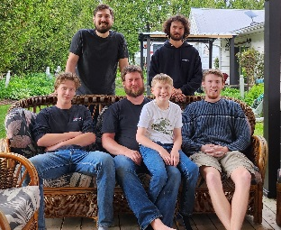Hello, my name is **Matt Porter**; I am interested in becoming director of **Zone 10** for Ontario Federation of Agriculture. My family and I farm 115 Km east Toronto and 3 km from the village of Millbrook. On our farm we have a small cow calf and field crop operation that includes corn, beans and small grains and a small fruit and vegetable stand. I work off the farm at Trent University in the School of the Environment and my research focuses are heavy metal contamination in food crops, farmland use and sustainable economics in agriculture. I am interested in the role because I believe my role as a local director to be useful and meaningful; I feel I can keep learning about how the OFA both works and how I could be apart of the story. In my time as a local director, I have broadened my scope of engagement, some of the things that I can contribute are; science communication for a range of challenges, relationship building between difficult groups and knowledge transfers,.

[mporter@trentu.ca](mailto:mporter@trentu.ca)

705-559-7551 cell