Larry Davis

Candidate for Zone 3

Brant Haldimand and Norfolk

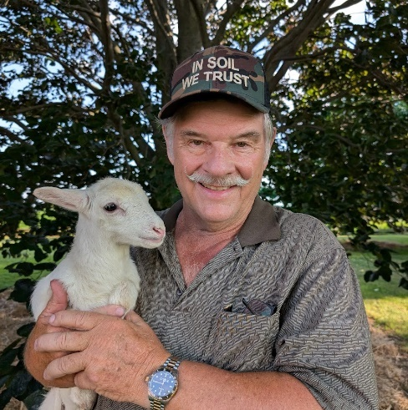

* OFA Director
* Past President Brant County Soil Crop Improvement Assn.
* Founding Director of IGPC Ethanol in Aylmer
* Founding Director of Ontario Biomass Producer’s Co op
* Founding Director of Ontario Hay and Forage Marketing Co op
* Past Regional Chair of Ontario Corn Producers Assn.
* Past Chair, Brant Resource Stewardship Network under the MNR
* Past President of Burford Agricultural Society
* Director on Burford Saddle Club and their show MC
* Director for CNE Board Representing Agriculture
* Town Crier for Brant County

I am a third generation dairy farmer and started driving farm machinery at the age of 8 as soon as my feet could reach the pedals. Brant County is where I farm with my wife and 2 children. As a Dairy Farmer I was privileged to be asked by my MPP to speak to the US House of Representatives and Senators about Supply Management. The dairy cows, however, were sold in 2006 but we continued growing 375 acres of corn, soybeans, and hay on the home farm, plus renting land to grow crops and started a small flock of sheep.

Soil and land preservation has always been my passion. In fact, I helped develop the Environmental Farm Plan and presented the first plans in Brant County. The future of Brant, Haldimand and Norfolk is dependent on the practices I support and continually practice with the soil on my farm. These three counties provide food, fiber, fuel and flowers for Ontario, Canada, and the world. Farmers produce over 200 agricultural products that are a direct result of the rich soil and our farmers. I Have served on many committees for the OFA including one where the Ministry of Energy appointed me. As your OFA director, I would continue to lobby for good policy/regulations for farmers by carrying OFA’s message to politicians and consumers for the mutual goal of protecting our ***Farms and Food Forever***. Please support me with your vote to be your Director on the OFA Board.

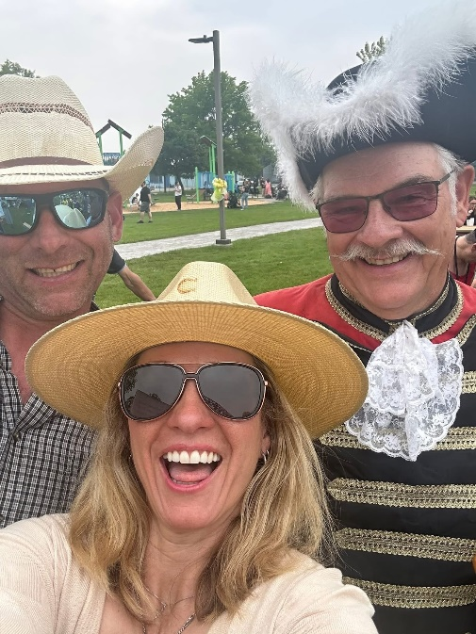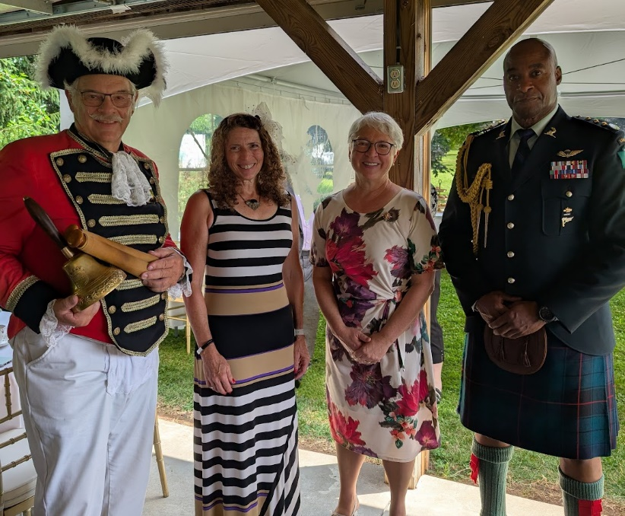

Larry Davis, Sally Davis, Lieutenant Governor of Ontario, Her Honour Edith Dumont, aide-de-camp Capt. Ray Joseph

At The Adelaide Hunter Hoodless Homestead in Brant County

Haldimand Councilor Brad Adams

MPP Bobby Ann Brady

Larry Davis at Ag Days

At the Hagersville 150th celebration