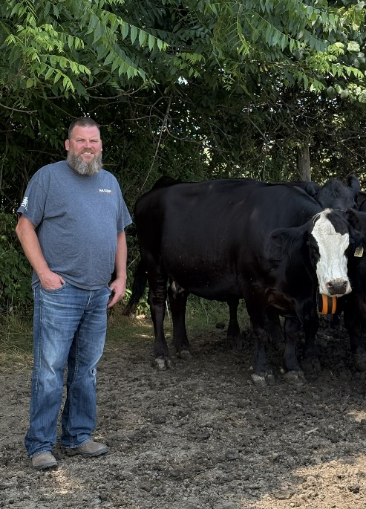
Hello my name is Henry Lise, I live between Hagersville and Caledonia in Haldimand County where I am a broiler chicken and cow-calf farmer with my wife Jackie and our four kids, Tyson, Abby, Jenessa, and Owen.
Agriculture is a very encouraging and exciting business to be in. I was raised on a farm and went on my own in 1997. Since then, there have been many challenges and changes to Agriculture, we have learned a lot and continue to see challenges around us. My diversity in supply managed and non supply managed sectors gives me the opportunity and understanding to see how Agriculture is different in its many viable sectors and the important role they all play across our zone and province.
My involvement in agriculture has developed over the past 20years, serving as a District Committee Rep for the Chicken Farmers of Ontario from 2005-2011, as a Board Director from 2011-2017 and a DCR again from 2019 to present. I have been a member of the Haldimand Federation since 2009, serving as President from 2019 -2023, a PAC member for several years, and currently sit on the Haldimand County Agricultural Advisory Committee.
A few highlights for me were working with the OFA, Haldimand Federation of Agriculture, the Ag Advisory Committee for Haldimand County and Haldimand County Council to implement and educate the need for the Emily Project – Farm 911 signs. As well as the Meet Your Local Farmer tent at the Caledonia Fair, The CFO booth at the Royal, and lobby days at Queens Park and Parliament Hill.
Through the AALP program (Class 13) and governance programs at Rotmans School of Business have I have learned a key priority as a director is building effective stakeholder relationships and listening to both sides of an issue will help people find common ground to move agriculture forward and create sustainable solutions.
I look forward to representing Brant, Haldimand and Norfolk as your future director, working with the OFA board and advocating on your behalf.
Please feel free to contact me if you have any questions, I appreciate your consideration.
Thanks
Henry Lise
9053085132 * Henklise14@gmail.com

